# 

# Computer Games Development CW208

# Technical Design Document

# Year IV

## Dylan Curran

## C00217112

## 03/05/2020

**Computer Games Development CW208** **1**

**Technical Design Document** **1**

**Year IV** **1**

Dylan Curran 1

C00217112 1

03/05/2020 1

**Class Diagram** **3**

**CRC Cards** **3**

**Features for the Game** **4**

Feature 1: Player Controller 4

Task 1: Set up the player. 4

Feature 2: House 4

Task 1A: Set up the house 4

Task 1B: Set up Minimalist house 5

Feature 3: AI Implementation 5

Task 1: Set up a basic AI 5

Feature 4: NavMesh Component 5

Task 1: Set up NavMesh 5

Feature 5: Collectible Component 6

Task 1 create the collectibles 6

# 

# Class Diagram

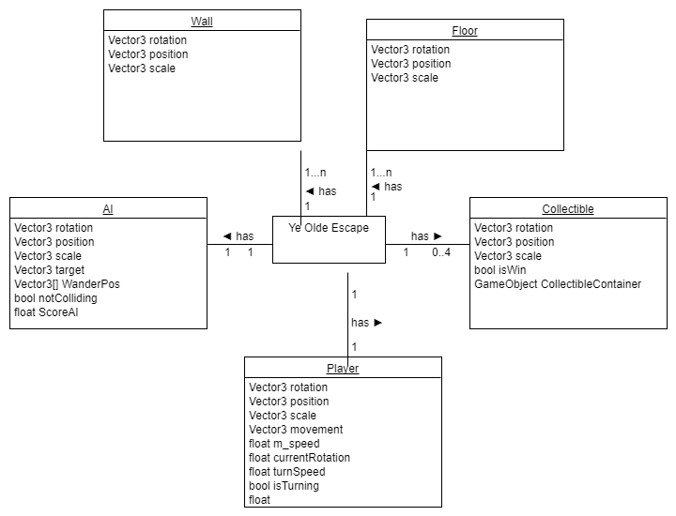

# CRC Cards

|  |  |
| --- | --- |
| Class Name: Player | Class Name: AI |
| SubClass:N/A | SubClass: N/A |
| SuperClass:n/A | SuperClass: N/A |
| Responsibilities: Allow the player to control this character to interact with the game | Responsibilities: Must target and hunt the player whilst learning to play better through gameplay. |
| Collaborators: Dylan Curran | Collaborators: Dylan Curran |

|  |  |
| --- | --- |
| Class Name: Collectible | Class Name: Level |
| SubClass:N/A | SubClass:Wall, Floor |
| SuperClass: N/A | SuperClass: N/A |
| Responsibilities: Must be collected by the player to pass the level. | Responsibilities: To ensure the player can be kept within bounds without falling off of the map. |
| Collaborators: Dylan Curran | Collaborators: Dylan Curran |

# Features for the Game

## Feature 1: Player Controller

### Task 1: Set up the player.

* Create a cube from the hierarchy menu.
* Label the cube with a “Player” layer and tag
* Create a script called “MovePlayer” that can move the player based on directional input using the W and S keys going forward and backwards.
* This script should also have the player rotating with the A and D keys left and right respectively.
* The movement should then be based on a 5 unit speed multiplied by the current angle for each axis.

## Feature 2: House

### Task 1A: Set up the house

* Go to the assets store.
* Get the build a house workshop assets and download it from the store.
* Drag and drop the assets so they line up properly to make a house that is two storeys high. Use mostly the wall section 1A for all of the external walls.

### Task 1B: Set up Minimalist house

* Create a cube in the scene for a wall and a floor. Create 3 cubes for the advanced wall.
* For the floor reset the position and scale the cube by 10 in the x and z axis. In the Y axis scale it by 0.1.
* For the basic wall cube scale it by 10 in the X , 5 in the Y axis and for the Z axis scale it by 0.1.
* After this line up the wall cube with the outer edge of the wall.
* For the advanced wall scale two of the cube to 4 on the X axis, 5 on the Y axis and 0.1 on the X axis, leaving a gap of two units between the 2 cubes to make a doorway to enter.
* With the last cube scale the X axis to 2, the Y axis to 3 and the Z axis to 0.1.
* Save all of these designed objects to a prefab folder, then drag and drop them to create a 2x2 floor with basic walls surrounding it and advanced walls crossing the floor.

## Feature 3: AI Implementation

### Task 1: Set up a basic AI

* Create a cube from the hierarchy.
* Create a script and ensure the script chases the player at all times.
* Ensure the Ai wanders to other locations if they cannot find the player.
* Check for collisions with other objects to ensure it works.

## Feature 4: NavMesh Component

### Task 1: Set up NavMesh

* Add a navmesh surface to an empty game object.
* When the level is made, bake the navmesh to ensure it takes the level into account.
* Ensure Ai is marked as an agent for the navmesh.
* Mark objects that get in the way as navmesh obstacles.
* Ignore the player and the collectibles from the Navmesh build.

## Feature 5: Collectible Component

### Task 1 create the collectibles

* Add an empty game object called collectibleContainer.
* Create a cube in Unity and set it’s scale to 0.2 in all axes and raise it by 0.5 in the Y axis.
* Ensure the cube can only be collided with by the player.
* If the player collects 4 of these they win the level.